Katrina Mallett – n9450866

Personal Portfolio

IFB299 – Application Design and Development

# Release One

**Artefact One: Site Map**The site map as shown below depicts how the user will be able to navigate the website. This is achieved by displaying a header with the essential pages to run the website (events, about, home and contact). The login is shown on the home page for members to login to see their donation history and to RSVP to events. This has been altered on the actual website from “registration” to “login” where they can either login with an existing account or register for a new account.

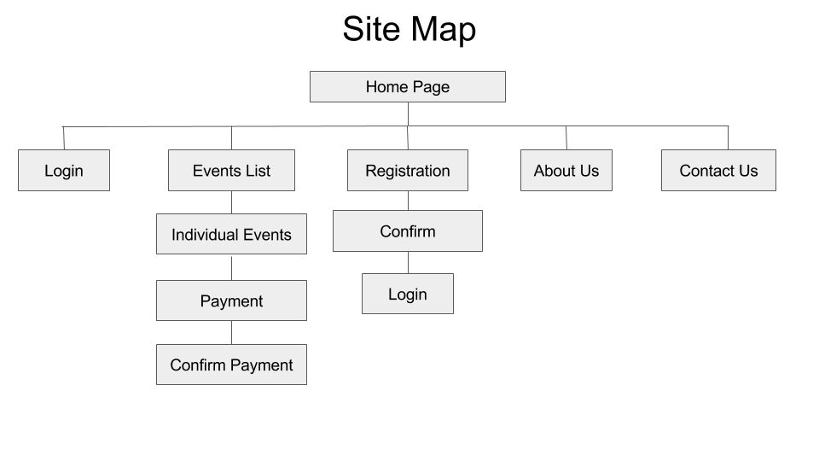

*Figure 1 – Website Site Map*

**Artefact Two: Page Flow**The page flow displayed below shows at what point information from the website is connecting to the database as well as showing the different options for users depending on their status (logged in, user or admin).

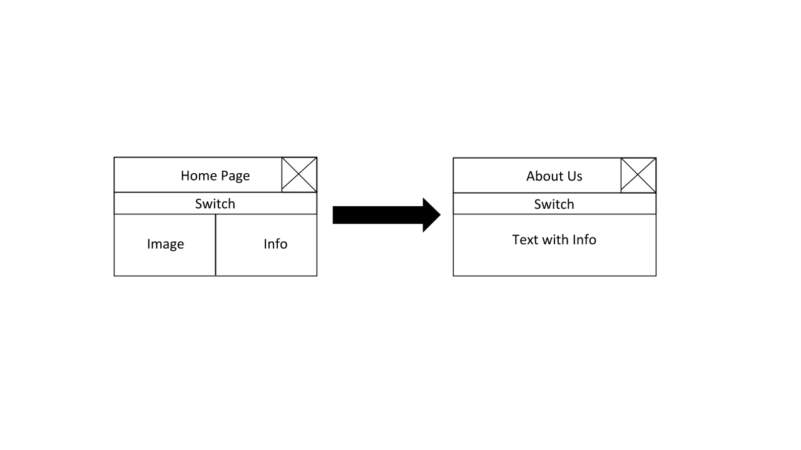  
*Figure 2 – About Us Page Flow*

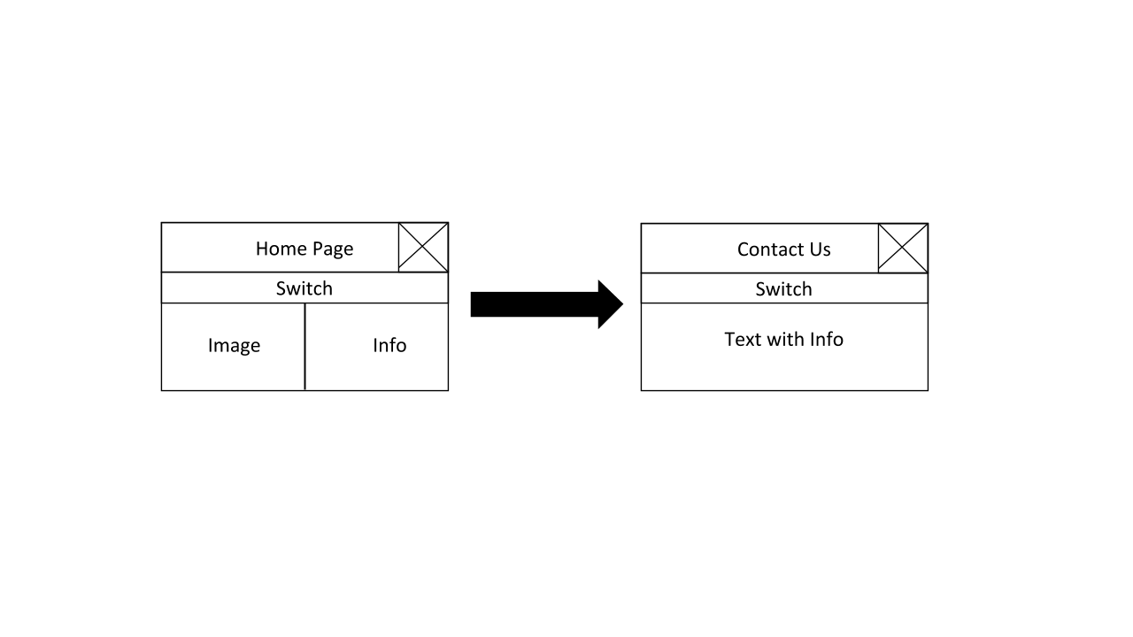

*Figure 3 – Contact Us Page Flow*

*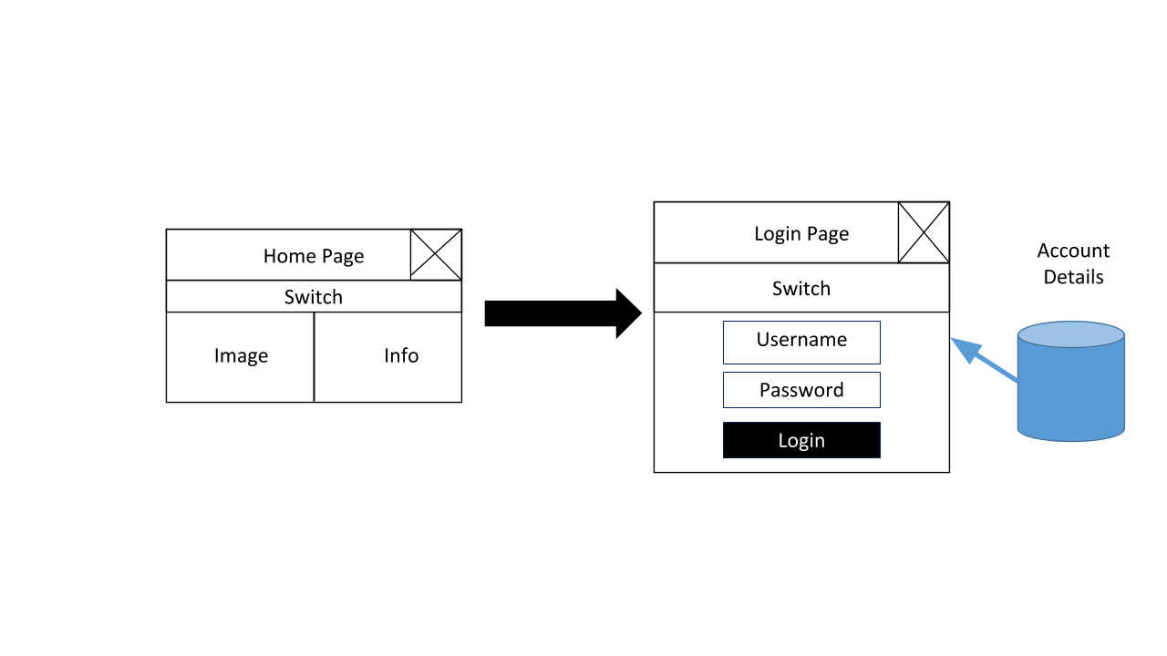*

*Figure 4 – Login Page Flow*

*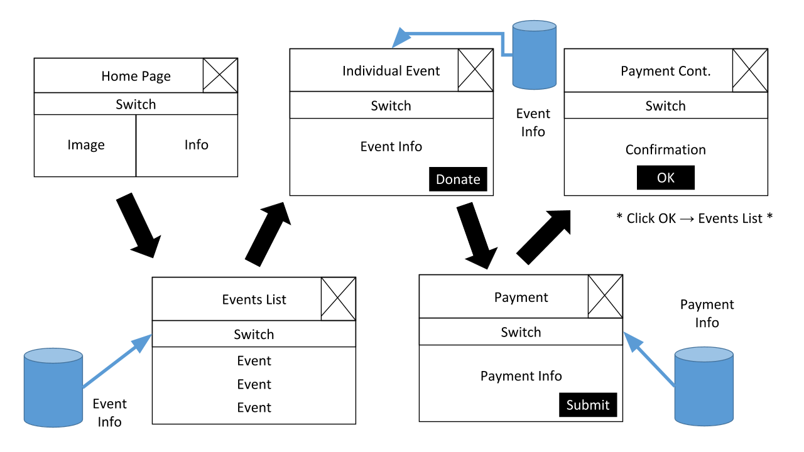*

*Figure 5 – Events Page Flow*

*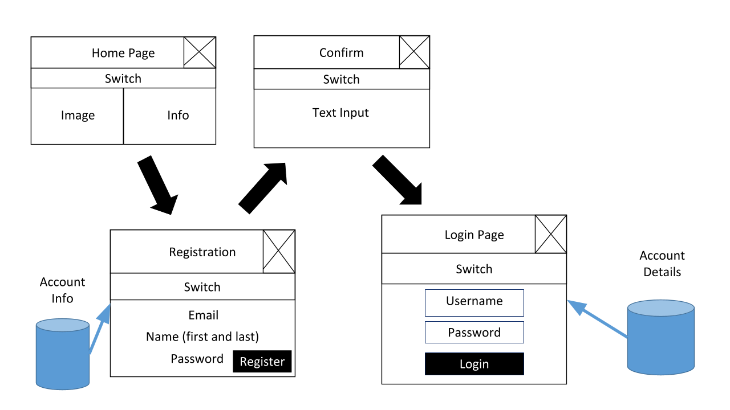*

*Figure 6 – Registration Page Flow*

**Artefact Three: Design Specifications**The design specification is displayed by a mock-up webpage of the events and home screen page, this is our base design we used for the website and decided to only do these two screens as these are the core part of our services.

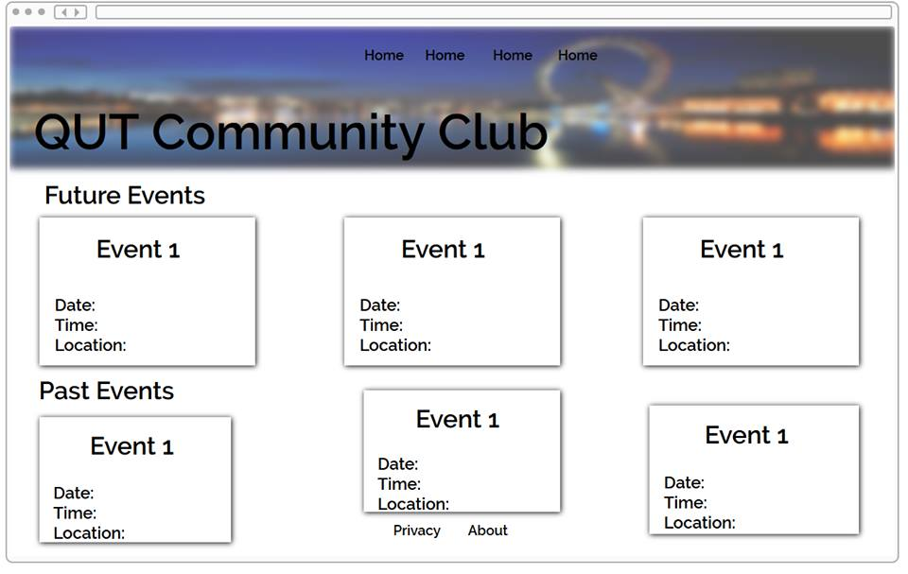*Figure 7 – Design Specifications – Events Page*  
*Figure 8 – Design Specifications – Home Page*

**Artefact Four: Client Interaction Summary (Release One)**The client interaction summary as shown below displays the interactions and remarks made by the client team during the release one stage of the project.

Client Interaction Summary – Week 9

* interaction began when the client contacted us requiring a web application for their organisation
* we kept in close contact with the client team as requirements were set within the first 2 weeks, following this the development team (us) created user stories to suit their target audiences for the web application and ensuring that every aspect was covered prior to commencing implementation.
* Acceptance criteria was created for the user stories based off what the client deemed the user story was completed by (testing material), this is to ensure the development team has implemented each story correctly and within scope.
* User stories were required to be revised due to being overloaded with a total of 75 user stories, many of these were redundant due to duplication and the development team decided which were best suited for the project and defined in conjunction with the client team to ensure they are happy with the alterations to the user stories.
* After 5 weeks of defining the requirements and user stories we met with the clients in a professional meeting setting to present our progress and to ensure this covers all of their requirements and do not request further abilities of the web application.
* After this meeting the development team began to implement the solution
* in week 7 of the project a presentation was made with progress of the web application, as the implementation of the web application was split into releases and sprints based off priority.
* The prioritisations were originally based off the development team’s recommendation, the fundamentals of the web application are positioned at the highest priority (e.g. database) as they are a primary key within the project and required for the rest of the web application to be implemented. Throughout the meeting the client team agreed on these prioritisations.
* Throughout the 8th week of the project, a professional business letter was sent to the client as official documentation of progress within the project.
* Release plans have currently not been required to be renegotiated as everything has been completed on time and as to the release plan.

*Figure 10 – Client Interaction Summary One*

**Artefact Five: Release and Sprint Plan (Updating)**The release and sprint plan are updated continuously throughout the project to display how we are progressing throughout our development. Throughout the first release I input all the tasks and how long each should take in comparison to how long it actually took. The inputting of data assists us to improve in the future.

**Release Plan**

**Release 1**

Delivery date: 22 September, 2016 Total Story Points: 36

the goals for this release is to have the basic functions of the website completely functioning so that we can start entering the highest priority user stories.

**Home Page and Design**

Users will be able to get an insight into what the organisation is about without being a member. Users are able to easily move around the website via the navigation panel.

|  |  |  |
| --- | --- | --- |
| **Story ID** | **Story Title** | **Story Points** |
| **S28** | Getting to know the community | 2 |
| **S75** | Easy Navigation | 8 |
|  | Story Point Sub-Total: | 10 |

**Setup**

This will set up a clear and defined access area for all developers to enter any file and know where the location of all files are

|  |  |  |
| --- | --- | --- |
| **Story ID** | **Story Title** | **Story Points** |
| **S70** | Front end file access | 2 |
| **S71** | Clear site wide section files | 2 |
|  | Story Point Sub-Total: | 4 |

**About Page**

Users are provided with the history of the organisation.

|  |  |  |
| --- | --- | --- |
| **Story ID** | **Story Title** | **Story Points** |
| **S30** | Knowing the community well | 2 |
|  | Story Point Sub-Total: | 2 |

**Contact Page**

Users will be able to communicated to the organisation.

|  |  |  |
| --- | --- | --- |
| **Story ID** | **Story Title** | **Story Points** |
| **S13** | Communication to Event Organisers | 2 |
| **S3** | Access to detail of organisation’s members | 4 |
|  | Story Point Sub-Total: | 6 |

**Database**

The database is an essential item which will store all of our websites data

|  |  |  |
| --- | --- | --- |
| **Story ID** | **Story Title** | **Story Points** |
| **S69** | Database access | 4 |
|  | Story Point Sub-Total: | 4 |

**Login Page**

Users are able to login to the website as a member or visitor.

|  |  |  |
| --- | --- | --- |
| **Story ID** | **Story Title** | **Story Points** |
| **S07** | Site Security | 2 |
|  | Story Point Sub-Total: | 2 |

**Individual Event Page 1**

Users will be able to view a detailed page of information for every event listed in the ‘Event List Page’. For the future events, members will be able to choose to participate in the events they want.

|  |  |  |
| --- | --- | --- |
| **Story ID** | **Story Title** | **Story Points** |
| **S26** | Setting a fundraising goal | 2 |
| **S34** | Sponsor advertisement | 2 |
| **S35** | Event information | 4 |
|  | Story Point Sub-Total: | 8 |

**Sprint Plan**

# Sprint 1

Total Story Points: 16 Total Hours: 31

Current Velocity: 16

## S75: Easy Navigation

|  |  |  |  |
| --- | --- | --- | --- |
| **Task ID** | **Task Description** | **Estimate** | **Taken** |
| **T01** | Basic layout and site-wide design | 8hrs | 10hrs |
| **T02** | Headers and Footers | 4hrs | 2hrs |
| **T03** | CSS/Javascript animations and menus | 8hrs | 8hrs |
|  | Story Points: 8 Total Hours: | 20hrs | 22hrs |

## S28: Getting to know the community

|  |  |  |  |
| --- | --- | --- | --- |
| **Task ID** | **Task Description** | **Estimate** | **Taken** |
| **T04** | Basic Home Page Design | 8hrs | 10hrs |
|  | Story Points: 2 Total Hours: | 8 Hours | 10hrs |

## S70: Front end file access

|  |  |  |  |
| --- | --- | --- | --- |
| **Task ID** | **Task Description** | **Estimate** | **Taken** |
| **T05** | Correct Editing of File Names | 30min | 30min |
| **T06** | Set up the file structure for extra files | 30 min | 30 min |
|  | Story Points: 2 Total Hours: | 1 Hour | 1 hour |

## S71: Clear site wide section files

|  |  |  |  |
| --- | --- | --- | --- |
| **Task ID** | **Task Description** | **Estimate** | **Taken** |
| **T07** | Appropriate file naming | 30 min | 15 min |
| **T08** | Correct file location | 30 min | 15 min |
|  | Story Points: 2 Total Hours: | 1 Hour | 30 min |

## S30: Knowing the Community Well

|  |  |  |  |
| --- | --- | --- | --- |
| **Task ID** | **Task Description** | **Estimate** | **Taken** |
| **T09** | Create About Page | 1 Hour | 1 Hour |
|  | Story Points: 2 Total Hours: | 1 Hour | 1 Hour |

# Sprint 2

Total Story Points: 20 Total Hours: 55

Current Velocity: 18

## S13: Communication to Event Organisers

|  |  |  |  |
| --- | --- | --- | --- |
| **Task ID** | **Task Description** | **Estimate** | **Taken** |
| **T10** | Create contact page | 2hrs | 1 Hr |
|  | Story Points: 2 Total Hours: | 2hrs | 1hrs |

## S3: Access to detail of organisation’s members

|  |  |  |  |
| --- | --- | --- | --- |
| **Task ID** | **Task Description** | **Estimate** | **Taken** |
| **T11** | Populate database with members contact details | 2hrs | 4Hrs |
| **T12** | Access and display database from event or contact page | 6hrs | Not completed |
|  | Story Points: 4 Total Hours: | 8hrs | hrs |

## S26: Setting a fundraising goal

|  |  |  |  |
| --- | --- | --- | --- |
| **Task ID** | **Task Description** | **Estimate** | **Taken** |
| **T18** | Display event donation goal in event page | 1hr | 1 Hr |
|  | Story Points: 2 Total Hours: | 1hrs | 1 hrs |

## S69: Database access

|  |  |  |  |
| --- | --- | --- | --- |
| **Task ID** | **Task Description** | **Estimate** | **Taken** |
| **T13** | Creation of appropriate databases | 2hrs | 3hrs |
| **T14** | Link web pages to databases | 6hrs | 4Hrs |
|  | Story Points: 4 Total Hours: | 8hrs | 7hrs |

## S7: Site Security

|  |  |  |  |
| --- | --- | --- | --- |
| **Task ID** | **Task Description** | **Estimate** | **Taken** |
| **T15** | Create login page | 4hrs | 8Hrs |
| **T16** | Security for password and form | 2hrs | 6Hrs |
| **T17** | Form validation (possibly through PHP/JS) | 4hrs |  |
|  | Story Points: 2 Total Hours: | 10hrs | hrs |

## S34: Sponsor advertisement

|  |  |  |  |
| --- | --- | --- | --- |
| **Task ID** | **Task Description** | **Estimate** | **Taken** |
| **T19** | Display sponsor advertisement and information on event page | 1hr | 1 Hr |
|  | Story Points: 2 Total Hours: | 1hrs | 1 hrs |

## S35: Event information

|  |  |  |  |
| --- | --- | --- | --- |
| **Task ID** | **Task Description** | **Estimate** | **Taken** |
| **T20** | List basic information about events from database (Location, time etc.) | 4hrs | Not completed |
| **T21** | Display event description and further info(possibly dress code and picture) | 2hrs | 2 Hrs |
| **T22** | Display fundraiser goal and current donation count | 2hrs | 2 Hrs |
|  | Story Points: 4 Total Hours: | 8hrs | 4 hrs |

## S76: Design and Testing

|  |  |  |  |
| --- | --- | --- | --- |
| **Task ID** | **Task Description** | **Estimate** | **Taken** |
| **T23** | Peer Review | 5 Hrs | 4 Hrs |
| **T24** | Create and Update Burndown Charts | 4 Hrs | 4 Hrs |
| **T25** | Review Website | 1Hr | 1 Hr |
| **T26** | Summary of Interaction | 1 Hr | 1 Hr |
| **T27** | Create Design Mockup | 1 Hr | 2 Hrs |
| **T28** | Create Storyboard | 2hrs | 2 Hrs |
| **T29** | Create Page Flow | 2hrs | 2 Hrs |
| **T30** | Create Site Map | 1hrs | 1 Hrs |
|  | Story Points: 4 Total Hours: | 17hrs | 17hrs |

*Figure 11 – Release and Sprint Chart – Release One – Sprint One and Two*

# Release Two

**Artefact One: Testing (Sprint One)**As displayed below a testing document has been provided for each release. This testing includes such information as the user story that is being tested, its acceptance criteria, which completed the test for this user story and how the acceptance criteria have been met. This is typically displayed by a screenshot followed by a paragraph explaining each task we split the story into and how this acceptance criterion is achieved.

**Release One: Sprint One  
Testing Form: S75 - Easy Navigation**

**Completed By**  
Katrina

**User Story**  
As a Developer, i want to have fully functional code and highly executed design throughout the website

**Acceptance Criteria**  
Testing documents are provided showing each story is fully functional within the two releases and design is created as per design specifications

**Meeting Acceptance Criteria**

The acceptance criteria for this user story has been divided into multiple tasks, such as basic layout and site-wide design which has been configured so that clients can see information within the website.

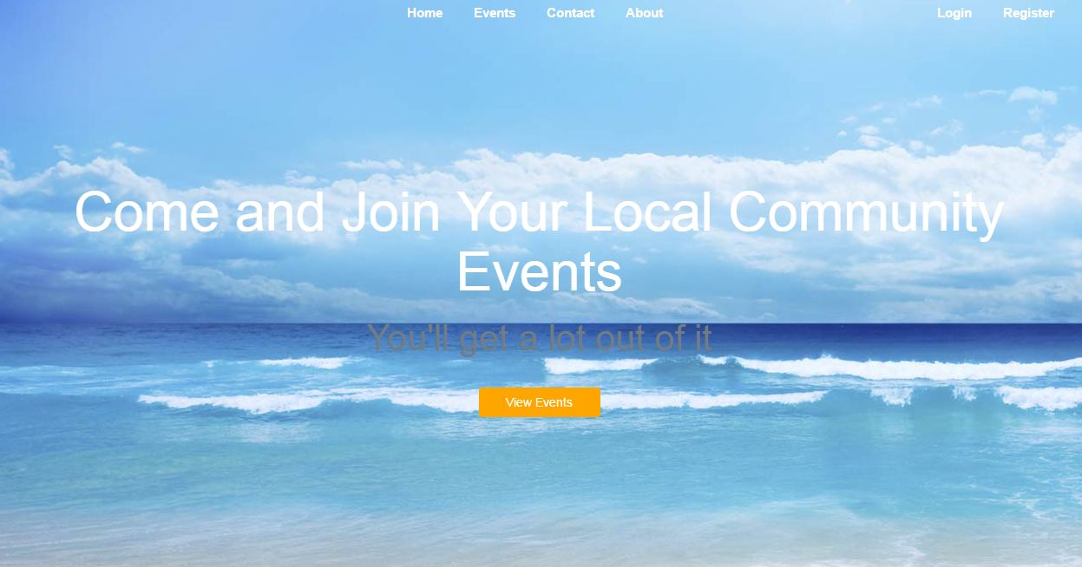

Headers and footers are implemented with the main links of the site staying on all pages of the website and CSS/Javascript animations and menus have been implemented where the user can select from a range of menus what they are looking for in particular. This story took 22 hours to complete.

s75_2.JPG

**Testing Form: S28 - Getting to Know the Community**

**Completed By**  
Katrina

**User Story**  
As a visitor, I want to be able to understand what the site is about and how it works without having to sign up.

**Acceptance Criteria**  
On the homepage of the website there will be information which briefly describes the community and the type of events which are held

**Meeting Acceptance Criteria**

The acceptance criteria for this user story has been broken down into one task for completion which is the creation of the website homepage. This has been completed showing some information about the type of website you are entering, however after a re-design to our intial user stories as a group we thought it would be best to leave this information for the website to explain and for people to find out more about in the “about” page in the webiste. This story took 10 hours to complete



**Testing Form: S70 - Front End File Access**

**Completed By**  
Katrina

**User Story**  
As a developer I want easy access to the files that are important for front end development (e.g. css and javascript files), so I can easily edit what is displayed to the people using the site

**Acceptance Criteria**  
A structured file setup with clear access to the extra files (CSS, Javascript .inc) and clearly named folders and files

**Meeting Acceptance Criteria**

This acceptance criteria has been broken down into 2 core tasks; correct editing of file names and setup the file structure for extra files. This can acceptance criteria can be shown as complete due to the careful labelling of everything within our github repository. This story took 1 hour to complete

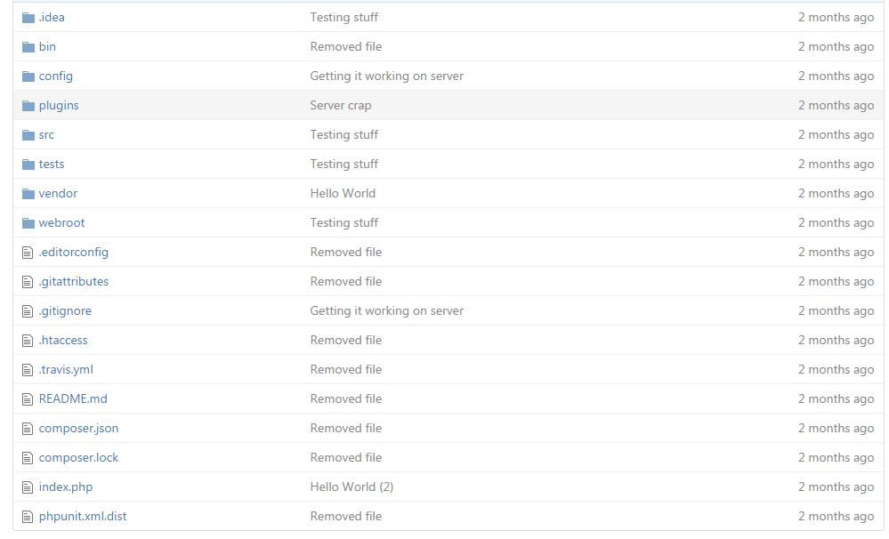

**Testing Form: S71 - Clear Site-Wide Section Files**

**Completed By**  
Katrina

**User Story**  
As a developer I want to be able to easily find and edit sections (most likely using .inc files) used across the whole site so time and effort editing is reduced

**Acceptance Criteria**  
Use of appropriate .inc files for headers/footers and aptly named .inc files in an appropriate folder location

**Meeting Acceptance Criteria**

This acceptance criteria has been completed by diving the story up into 2 specific tasks, appropriate file naming and correct file location. These are done to ensure that all of the current and correct information is displayed in the website rather than old information with the same name. This story took approximately 1 hour to complete.



**Testing Form: S30 - Knowing the Community Well**

**Completed By**  
Katrina

**User Story**  
As a visitor, I want to know in-depth information about the community so that I can better gauge my interest in joining it without having to be a member.

**Acceptance Criteria**  
There will be a separate ‘About’ page which has specific information about the community, including who’s involved and why the community was created

**Meeting Acceptance Criteria**

This acceptance criteria is met by creating an “about” page on the website which gives visitors and members a back story of the community organisation. The key roles within the organisation are stated (president, accountant, events coordinator, community communicator and model) as well as a slight intro about the organisation in a section called “a little about us”. This story took approximately 1 hour to complete.

## s30_1.JPG

*Figure 12 – Testing – Sprint One*

**Artefact Two: Release and Sprint Plan (Updating)**The release and sprint plan are updated continuously throughout the project to display how we are progressing throughout our development. Throughout the second release I input all the tasks and how long each should take in comparison to how long it actually took. The inputting of data assists us to improve in the future.

# Release 2

Delivery date: 27 October, 2016 Total Story Points: 62

This release focuses on the highest priority user stories and ensuring the implementation in a high quality

## Event List Page Users will be able to view all of the past and future events that the organisation has organised. The date and location are shown for each event.

|  |  |  |
| --- | --- | --- |
| **Story ID** | **Story Title** | **Story Points** |
| **S33** | Choosing events | 4 |
| **S6** | Viewing Past and Future Events | 8 |
| **S12** | Communication from Sponsors | 2 |
|  | Story Point Sub-Total: | 14 |

## Individual Event Page 2 Users will be able to view a detailed page of information for every event listed in the ‘Event List Page’. For the future events, members will be able to choose to participate in the events they want.

|  |  |  |
| --- | --- | --- |
| **Story ID** | **Story Title** | **Story Points** |
| **S15** | Roster Details | 4 |
| **S01** | Editing detail of events | 4 |
| **S02** | Tracking the number of attendees | 2 |
| **S04** | Event Cost Approximation | 4 |
|  | Story Point Sub-Total: | 14 |

## Ticket Page User will be able to donate to any future events that they want.

|  |  |  |
| --- | --- | --- |
| **Story ID** | **Story Title** | **Story Points** |
| **S11** | Money Control | 8 |
| **S17** | Giving Donations | 16 |
|  | Story Point Sub-Total: | 24 |

## Registration Page Users will be able to register as a member of the organisation.

|  |  |  |
| --- | --- | --- |
| **Story ID** | **Story Title** | **Story Points** |
| **S05** | Visitor Registration | 2 |
|  | Story Point Sub-Total: | 2 |

## Website Security and Error Reporting

This is to ensure that all information stored about the website is secure at all times using various security inputs

|  |  |  |
| --- | --- | --- |
| **Story ID** | **Story Title** | **Story Points** |
| **S72** | Error Messages | 2 |
| **S14** | Security | 2 |
| **S07** | Site Security | 2 |
| **S10** | Password Security | 2 |
|  | Story Point Sub-Total: | 8 |

# Sprint 3

Total Story Points: 34 Total Hours: 36

Current Velocity: 23

## S3: Access to detail of organisation’s members

|  |  |  |  |
| --- | --- | --- | --- |
| **Task ID** | **Task Description** | **Estimate** | **Taken** |
| **T11** | Populate database with members contact details | 2hrs | 2hrs |
| **T12** | Access and display database from event or contact page | 6hrs | 6hrs |
|  | Story Points: 4 Total Hours: | 8hrs | 8hrs |

## S7: Site Security

|  |  |  |  |
| --- | --- | --- | --- |
| **Task ID** | **Task Description** | **Estimate** | **Taken** |
| **T15** | Create login and registration page | 4hrs | 8Hrs |
| **T16** | Security for password and form | 2hrs | 6Hrs |
| **T17** | Form validation (possibly through PHP/JS) | 4hrs | 2hrs |
|  | Story Points: 2 Total Hours: | 10hrs | 16hrs |

## S35: Event information

|  |  |  |  |
| --- | --- | --- | --- |
| **Task ID** | **Task Description** | **Estimate** | **Taken** |
| **T20** | List basic information about events from database (Location, time etc.) | 4hrs | 6hrs |
| **T21** | Display event description and further info(possibly dress code and picture) | 2hrs | 2 Hrs |
| **T22** | Display fundraiser goal and current donation count | 2hrs | 2 Hrs |
|  | Story Points: 4 Total Hours: | 8hrs | 10hrs |

## S05: Visitor Registration

|  |  |  |  |
| --- | --- | --- | --- |
| **Task ID** | **Task Description** | **Estimate** | **Taken** |
| **T31** | Create registration page | 4hrs | 4Hrs |
|  | Story Points:  2 Total Hours: | 4 hrs | 4 hrs |

## S02: Tracking the number of attendees

|  |  |  |  |
| --- | --- | --- | --- |
| **Task ID** | **Task Description** | **Estimate** | **Taken** |
| **T32** | Add counter to Attendance button | 1 Hr | 1hr |
| **T33** | Display Counter | 1 Hr | 1hr |
|  | Story Points: 2 Total Hours: | 2 hrs | 2hrs |

## S04: Event Cost Approximation

|  |  |  |  |
| --- | --- | --- | --- |
| **Task ID** | **Task Description** | **Estimate** | **Taken** |
| **T34** | Find and Input total cost of event in database | 1 Hr | 1 |
| **T35** | Display if any costs are required for each individual event | 1 Hr | 1 |
|  | Story Points: 4 Total Hours: | 4 hrs | 2hrs |

## S06: Viewing Past and Future Events

|  |  |  |  |
| --- | --- | --- | --- |
| **Task ID** | **Task Description** | **Estimate** | **Taken** |
| **T36** | Design event page with multiple events | 2 Hrs | 2 Hrs |
| **T37** | Ensure previous events stay on the events page for members to view | 1 Hr | 1 Hr |
|  | Story Points: 8 Total Hours: | 3 hrs | 3 hrs |

## S33: Choosing events

|  |  |  |  |
| --- | --- | --- | --- |
| **Task ID** | **Task Description** | **Estimate** | **Taken** |
| **T38** | Having a range of events available for members to view | 1 Hr | 1 Hr |
|  | Story Points: 4 Total Hours: | 1 hrs | 1 Hr |

## S15: Roster Details

|  |  |  |  |
| --- | --- | --- | --- |
| **Task ID** | **Task Description** | **Estimate** | **Taken** |
| **T39** | Create roster in database from volunteers input | 1 hr | 1hr |
| **T40** | Display roster from the database in each individual event page | 2 Hr | 2hr |
|  | Story Points: 4 Total Hours: | 3 hrs | 4hrs |

# Sprint 4

Total Story Points: 36 Total Hours:40

Current Velocity: 27

## S12: Communication from Sponsors

|  |  |  |  |
| --- | --- | --- | --- |
| **Task ID** | **Task Description** | **Estimate** | **Taken** |
| **T46** | Display event information (time, date, location) | 1 hr | 1 hr |
|  | Story Points: 2 Total Hours: | 1 hrs | 1 hrs |

## S01: Editing detail of events ben

|  |  |  |  |
| --- | --- | --- | --- |
| **Task ID** | **Task Description** | **Estimate** | **Taken** |
| **T47** | Input edit button on each individual event page | 4 Hr | Ben |
| **T48** | Create new page which allows planners to edit the time, date and location of events | 2 Hr | Ben |
| **T49** | Create admin users | 6 hr |  |
|  | Story Points: 4 Total Hours: | 2 hrs | hrs |

## S11: Money Control jonny

|  |  |  |  |
| --- | --- | --- | --- |
| **Task ID** | **Task Description** | **Estimate** | **Taken** |
| **T50** | Create personal tracker to be displayed on member login | 2 Hr | 1 hr |
| **T51** | Display personal tracker in Events Page | 1 Hr | 2 hrs |
| **T52** | Add to current donation total for individual event | 2 Hr | 1 hr |
|  | Story Points: 8 Total Hours: | 5 hrs | 4 hrs |

## S17: Giving Donations kihoon

|  |  |  |  |
| --- | --- | --- | --- |
| **Task ID** | **Task Description** | **Estimate** | **Taken** |
| **T53** | New Payment Page | 2 Hr | 5 |
| **T54** | Confirm Payment Page | 1 Hr | - |
| **T55** | Security of information (credit card details) | 2 hr |  |
| **T56** | Implement and populate donation database | 1 hr | 1 |
|  | Story Points:  16 Total Hours: | 5 hrs | hrs |

## S72: Error Messages jonny

|  |  |  |  |
| --- | --- | --- | --- |
| **Task ID** | **Task Description** | **Estimate** | **Taken** |
| **T57** | 404 Error Page | 1 hr | 1 hr |
| **T58** | Error Pop-Up Boxes throughout website where necessary | Cancelled | |
|  | Story Points: 2 Total Hours: | 2 hrs | hrs |

## S14: Security

|  |  |  |  |
| --- | --- | --- | --- |
| **Task ID** | **Task Description** | **Estimate** | **Taken** |
| **T59** | Create random salt generation for passwords | 1 Hr | 1 Hr |
|  | Story Points: 2 Total Hours: | 1 hrs | 1 hrs |

## S10: Password Security

|  |  |  |  |
| --- | --- | --- | --- |
| **Task ID** | **Task Description** | **Estimate** | **Taken** |
| **T60** | Concatenate password generation | 1 Hr | 1 Hr |
|  | Story Points: 2 Total Hours: | 1 hrs | 1 hrs |

## S76: Design and Testing

|  |  |  |  |
| --- | --- | --- | --- |
| **Task ID** | **Task Description** | **Estimate** | **Taken** |
| **T23** | Peer Review | 5 Hrs | 4 Hrs |
| **T24** | Create and Update Burndown Charts | 4 Hrs | 4 Hrs |
| **T25** | Testing | 20Hr | 15 Hr |
| **T26** | Summary of Client Interaction | 1 Hr | 1 Hr |
|  | Story Points: 4 Total Hours: | 30hrs | 24hrs |

*Figure 13 – Release and Sprint Plan – Release Two – Sprint Three and Four*

**Artefact Three: Proof Reading Peer Review Prior to Submission**In our 11th week of the project we met with the development team (team 94 as the clients) and was given an update and progression update of their project. This is documented via a peer review which is written by another team member, however I reviewed this document for any spelling/grammatical errors and ensured it had everything the development team would need to be able to improve for the end of release two.

**Client Team 94**

James Skidmore – n9146661

Benjamin McColm-Pickford - n8847762

Jonny Vukim - n9470921

Kihoon Seo - n8998949

Katrina Mallett - n9450866

Joel Perry - n9173471

October 18, 2016

Package Delivery Development Team 93

QUT Community Organisation

2 George Street

Brisbane, Queensland 4000

Dear Development Team:

I am writing to you as your client concerning the latest demonstration of your development project. On the the 13th of October 2016 your development team demonstrated the latest content and provided an update on the current version of the project and the technical work that has been completed regarding a website for the delivery company owned by Bill.

Much along the lines of the first progress presentation I would again like to commend your development team on their overall product so far. The team was prepared and confident in presenting the product and answering any questions relating to the development of the product to date. The presentation went along quite well except for one small error which was easily fixed. All story cards relating to this sprint were also discussed to see if the acceptance criteria was met or if any problems were encountered.

Continuing from your last presentation there was a set of expectations that were set regarding the content that should be completed and ready to be showed for the most recent presentation. It is my pleasure to inform you that your developed content so far has been far ahead of what was expected. Each of the story cards regarding the sprint plan were mainly completed and work that wasn’t expected to be done was also already completed or started to be worked on. The members presenting the product also came across extremely confident in the product they had developed to date and were able to explain anything regarding the product. The product is far ahead of what is expected and also delivers great business value. The group did come across some difficulties within this presentation regarding sprint 4 material, this was resolved by showing one part of the website on a local machine as the product wouldn’t get pushed to the final website for an unknown reason. This was not an issue though as this part of the product wasn’t meant to be shown yet and shows the confidence and ability your team has in developing this product.

. In addition to this one user story that was set to be released within this sprint was not completed due to the team no longer finding this user story necessary due to a change of plans, this was carefully and meticulously explained to us as the clients and we are happy and respect their decision not to move forward with this user story.

During the product demonstration no technical difficulties occurred as the presentation was presented at the right level for all the stakeholders. The system architecture explained by the developing team was well defined and shown to be suitable for the project with no defects in the presentation detected. Your team has gone ahead and researched everything and discussed why you made these choices so I am unable to provide much feedback regarding ways to improve as your product is of an extremely high quality already. As stated previously, there was a small issue regarding the routing aspect of the product but that was solved by demonstrating it on a local machine.

The professionalism of the presentation requires improvement in the future as a more formal and rehearsed presentation is expected throughout the rest of the project, however, all content was covered with quality information. The members presenting the product were coherent and confident in their knowledge of the product to date. Each question regarding the product and how the work was completed was answered to a satisfactory level with every member of the development team seeming to be involved in helping create the product. As the presentation was performed ad hoc it did mean that there were some parts that were probably not discussed to their fullest potential but this can be easily fixed by spending a short time preparing well for the presentation.

Recommendations for the team moving forward is to obtain a higher level of professionalism when producing their work to match the strong content provided and to ensure that all issues with user stories are identified and notified to us as the client team as soon as possible.

In conclusion, the presentation of the product was conducted at a high level by the development team. The demonstration was clearly prepared and provide us, as the client, with knowledge that the project is keeping to the precise time schedule and completing mostly all required story cards with their acceptance criteria.

Sincerely,

Bill’s Delivery Service Melbourne

*Figure 14 – Peer Review - Two*

**Artefact Four: Client Interaction Summary (Release Two)**The client interaction summary as shown below displays the interactions and remarks made by the client team during the release one stage of the project.

**Client Interaction Summary**

**Release 2 Beginning Date: 22nd of September 2016  
Release 2 End Date: 27th of October 2016**

* In week 9 of the project a presentation was made with progress of the web application, as the implementation of the web application was split into releases and sprints based off priority.
* Discussed with the client’s improvements that could be made to the website and if any extra altercations were required (this was discussed at the end of release one)
* We discussed how our team had not completely finished all stories at the end of release one and how we were going to address this moving forward.
* On the 6th of October, we met with the client team briefly to give them a progress update and ensure them that the outstanding user stories that have been dragged across from sprint one due to database connection problems had been fixed and now fully functional.
* Met with the client team again on the 13th of October 2016 to give them an official update on our website, the clients were happy with our progress and eager to see what our final product will look like.
* At this point we had showed them some testing of the website to prove that it fits our acceptance criteria
* Throughout the 11th week of the project, a professional business letter was sent to the client as official documentation of progress within the project.
* On the 20th of October, we had a weekly meeting with our client to discuss work-in-progress, this was successful and are eager to see the final product next Thursday on the 27th of October
* On the 27th of October, we had our final interactions with the client team, we provided our final project and they were happy with our results and congratulated us on our efforts throughout the project.
* Final testing documents were shared with the client team to ensure they are aware we have met all acceptance criteria

*Figure 15 – Client Interaction Summary - Two*

**Artefact Five: Testing (Sprint Three)**As displayed below a testing document has been provided for each release. This testing includes such information as the user story that is being tested, its acceptance criteria, which completed the test for this user story and how the acceptance criteria have been met. This is typically displayed by a screenshot followed by a paragraph explaining each task we split the story into and how this acceptance criterion is achieved.  
 **Testing Form: S3 - Access to detail of organisation’s members**

**Completed By**  
Katrina

**User Story**  
As an event planner, I want to have a detailed database of all of the organization’s members, their roles and their contact details so that I can prepare appropriately.

**Acceptance Criteria**  
There will be a page to show information of people who participate in events and the members should be categorized (pre-sorted) by role type

**Meeting Acceptance Criteria**

This acceptance criteria is met by displaying a database in the contact page below the map and address, this shows the roles, names and contact information (email) as described on the user story. This story took approximately 8 hours to complete.

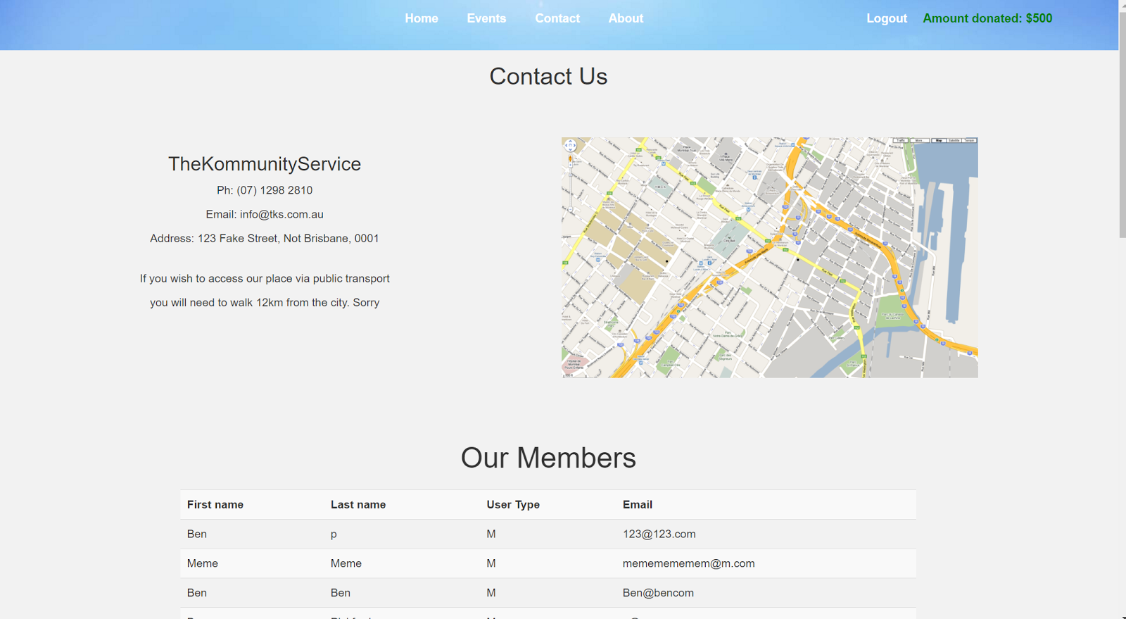

**Testing Form: S7 - Site Security**

**Completed By**  
Katrina

**User Story**  
As a member, I want to ensure that my password and other details are protected so that I can navigate the website safely

**Acceptance Criteria**  
For this to be accepted the development team has to put in place site security by having forms that are SQL Injection proof

**Meeting Acceptance Criteria**

This acceptance criteria is met by implementing code that makes forms SQL injection proof. SQL injection is a type of attack that occurs when an external string in concatenated into the websites query without using bind variables. This is completed within our website by the user not being able to change the eventID shown at the end of this URL address.   
*https://lh6.googleusercontent.com/XqJRwhnOzUzF8JLyfQ5RvmGiN-ia2hlgHfynmp0OyG3q5jcQ9o3igkqwlOJF5BDQ2TqW-4Q2JluOH3UQPi0qEWynMzwuObzWH2DeRS_th0hvUQ2E8lNeqx68LBZyK7m-nKBHSd5s*

If you change the eventID=3 to eventID=true the following error message will appear

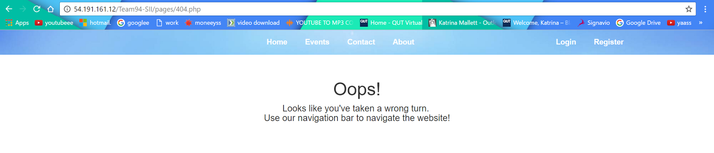

Therefore, making this SQL injection proof. This story took approximately 16 hours to complete.

**Testing Form: S35 - Event information**

**Completed By**  
Katrina

**User Story**  
As a member, I want to see information about what is happening at an event so that I can decide if I want to go.

**Acceptance Criteria**  
On the individual event pages, there will be a various amount of information displayed for users to see

**Meeting Acceptance Criteria**

This acceptance criteria is met by displaying information about each individual event on its own page. An example is shown where a future event information is shown and members can RSVP if they wish to attend the event. This story took approximately 10 hours to complete.

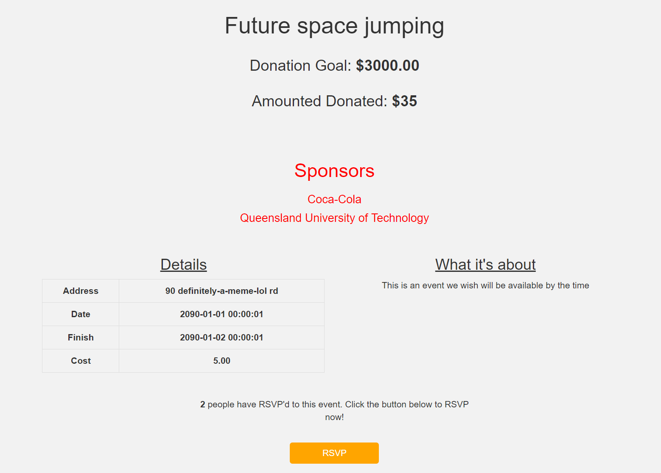

**Testing Form: S05 - Visitor Registration**

**Completed By**  
Katrina

**User Story**  
As a visitor, I want to be able to become a member easily online, so that I can become part of the community if I wish.

**Acceptance Criteria**  
There will be a registration page for visitors, where they are able to input their various details for logging in. Once the information is submitted it will be checked for errors or incomplete fields, then pushed to the database.

**Meeting Acceptance Criteria**

This acceptance criteria is met by displaying a registration page where visitors can become members

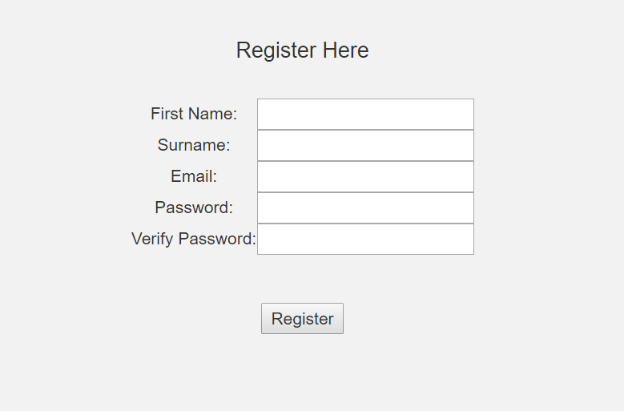

Following the user registering an account, providing they have entered in all the information correctly their information will be displayed in the system database with their user ID, first and last name, user type (e.g. member), their hashed password and the salt attached to the has for verification the next time they login. This story took approximately 4 hours to complete.

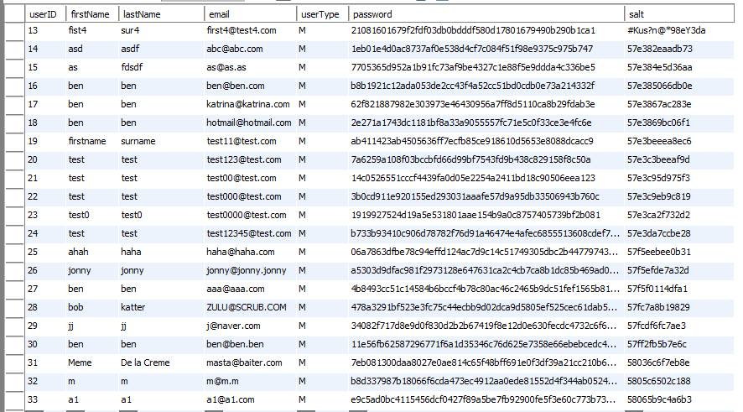

**Testing Form: S02 - Tracking the number of attendees**

**Completed By**  
Katrina

**User Story**  
As an event planner, I want to know exactly how many of the attending members will be bringing their family or friends so that I can prepare adequately.

**Acceptance Criteria**  
Event details including the number of attending members will be displayed for event planners on the individual event page.

**Meeting Acceptance Criteria**

This acceptance criteria is met by displaying the number of attendees via the RSVP button. Each time a user commits to attending the RSVP number is increased by 1 after donation details have been completed. This story took approximately 8 hours to complete.

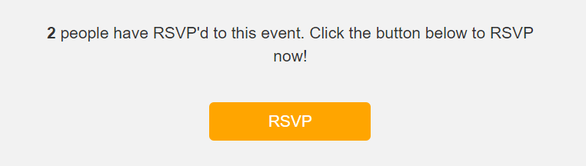

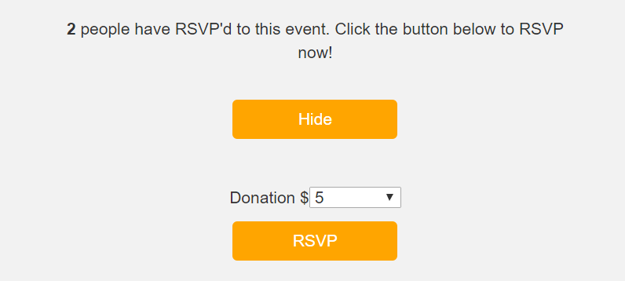

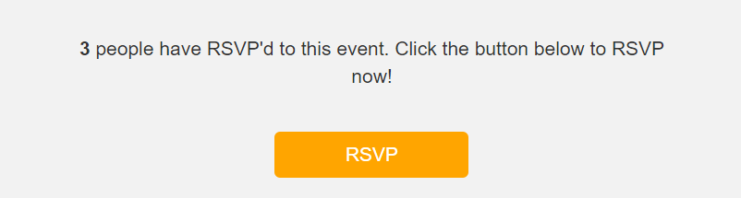

**Testing Form: S04 - Event Cost Approximation**

**Completed By**  
Katrina

**User Story**  
As an event planner, I want to be able to obtain an automatic approximation of the costs required to cater for an event so that I can get a general idea of the expenses for the event.

**Acceptance Criteria**  
When the Event Planner goes to the event page, there will be a section which shows the approximate cost of the event, considering the number of people going and it will only be shown after the RSVP date

**Meeting Acceptance Criteria**

This acceptance criteria is met by displaying the number of attendees attending each individual event. Though the acceptance criteria states that the cost can only be shown after the RSVP date we as a team decided to change this due to all members having to pay to get in, and showing them work-in-progress of what they have left to donate may encourage others to donate more or other people may donate in order to attend the event. This original decision was first based off the fact that not everyone had to pay to attend the event however this has been altered as it is compulsory to donate at least $5 to the event to attend. This story took approximately 2 hours to complete.   
  
  


**Testing Form: S06 - Viewing Past and Future Events**

**Completed By**  
Katrina

**User Story**  
As a visitor, I want to view past and future events to decide whether or not joining would be worthwhile.

**Acceptance Criteria**  
Visitors will be able to view a list of events that have already occurred and upcoming events on a page. The page will have clickable events which may be clicked on to show more information about the event

**Meeting Acceptance Criteria**

This acceptance criteria is met by displaying future and previous events in a large grid style, then following this individual links where visitors can find more information about each individual event. This story took approximately 3 hours to complete.

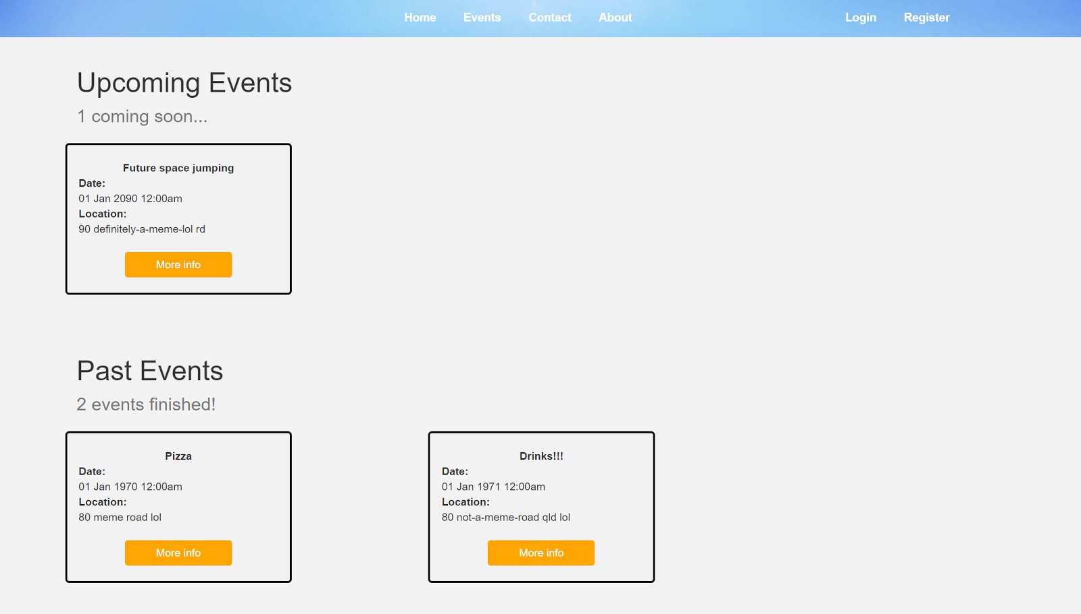

**Testing Form: S33 - Choosing events**

**Completed By**  
Katrina

**User Story**  
As a member, I want to be able to choose which events I want to attend so that I can socialise and go to what interests me.

**Acceptance Criteria**  
On the page with the list of events, users will be able to choose any event from the list, and purchase a ticket for them (if a future event, otherwise information about previous events will be displayed)

**Meeting Acceptance Criteria**

This acceptance criteria is met by displaying the main events page with information about the event such as time, date and place on one main screen, however following this further information is held inside each individual event about what it's about, the address and the cost. This story took approximately 1 hour to complete.





**Testing Form: S15 - Roster Details**

**Completed By**  
Katrina

**User Story**  
As a volunteer, I want to be able to view what days and times I’m rostered for so that I can plan my free time in advance.

**Acceptance Criteria**  
Each event displays a roster of everyone included to their involvement times

**Meeting Acceptance Criteria**

This acceptance criteria is met by displaying a table at the bottom of the individual event pages displaying available times for volunteers and if someone is working within a particular period of time. This story took approximately 4 hours to complete.

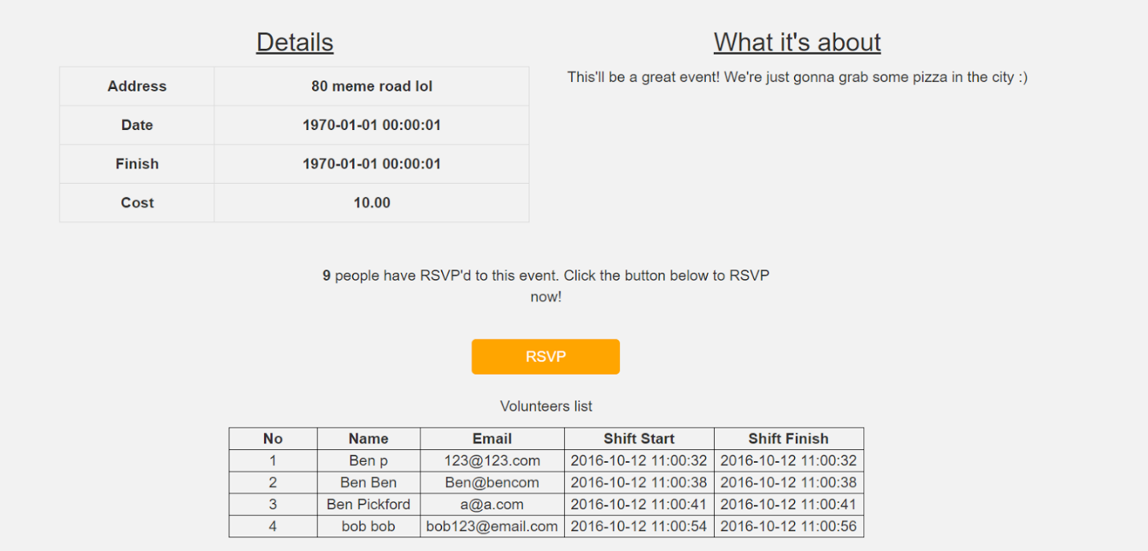

*Figure 16 – Testing – Sprint Three*